**Service-Learning Experience Reflection Paper**

**Max Gerber**

**GEB 4890**

**Dr. Geiger**

**Table of Contents**

**Initial Expectations –-------------------------------------------------------------------------------- Page 3**

**Applicable Disciplinary Skills -------------------------------------------------------------------– Page 3**

**My Contribution -----------------------------------------------------------------------------------– Page 5**

**Mission & Vision Expansion ---------------------------------------------------------------------– Page 5**

**Mission and Vision Revision Reflection -------------------------------------------------------– Page 7**

**Diversity Expansion –------------------------------------------------------------------------------- Page 8**

**Ethical Dilemmas and Leadership --------------------------------------------------------------– Page 9**

**Appendix –------------------------------------------------------------------------------------------- Page 10**

**Initial Expectations**

Many of us have had experience with volunteering, as most if not all of us have had to do it for some reason or another, weather it be for school or maybe just out of the goodness of your own heart. Personally, I have done volunteer work in the past for a soup kitchen in order to graduate from my medical program in high school. This time around, I chose to volunteer at an organization called “Friends of Strays”, which is an animal shelter located in St. Petersburg, Florida. I expected to enjoy doing this type of work because I’ve always been fond of animals, and even if volunteering with them involves “doing the dirty work” involved with animal care, it still wouldn’t phase me too much because I have a fairly strong gut. Growing up, I also had two cats and taking care of them I expected to be not too entirely different from working with the animals at the shelter. I expected most of what I would be doing there would include walking the dogs, washing the cats and dogs, feeding the animals, playing with the animals, and helping incoming customers pick out an animal that they would like to adopt. All the above turned out to be true, except for that I didn’t actually get to help people pick out an animal, that was left to the people who worked there; the volunteers served as more of a “physical labor” type of help. I also expected to have a lot of down time because even though there is a lot to do, most of the volunteering experience ends up being something to the extent of, “all of the work is already done, you might have to wait for a bit until there is something else to do.” My experience ended up being very busy and filled with work, which was nice because it made the time I spent there go faster and more enjoyable.

**Applicable Disciplinary Skills**

School and work (work / volunteering) both require a vast number of disciplinary skills. The same could be said for a physical workout regimen or caring for children. These types of duties that require you to think and act on behalf of something besides yourself and what you are directly dealing with in your life are very important things to be able to handle well, and a lot of the disciplinary skills I have acquired I can thank both USF and my work history for. Throughout my experience in my major at USF, it has trained my brain to be able to execute good time management, how to properly understand when a task is completed (not taking too much time on something because not everything can be “perfect”, but also not taking to little time on something because then the job won’t be complete), how to communicate with others and work with others on the task at hand, and how to properly plan out your day so not only can you get done the things that you need to get done in your everyday life, but also then set aside time to punctually arrive to and get done the work/homework/volunteering you might have to do, and still do it well. Studying for my major and working with others within the school system has been a great help to me, but what has also been a huge benefit to my life in general has been being in the workplace and understanding how that environment works. I would say that when you’re volunteering, you’re essentially just “working” without getting paid. How you interact with others is exactly the same as what many of us might be doing in our current workplace. I used to work at Starbucks, and I currently work at Aldi. I started working at Starbucks when I was 16 and that gave me a very early start on how to multitask the customer service aspect of the job with tasks that I had to complete around the store simultaneously. If anything, I would argue that volunteering at this shelter was much easier than working at Starbucks because they didn’t have me doing any of the customer service parts, it was just the physical labor parts. My current job at Aldi, in all honesty, is so ridiculously poorly managed and that work split is so unfair that any number of disciplinary skills required in any thing else (the volunteering work) will never top the ridiculous expectations of Aldi. if I can meet the expectations there (which I’m somehow doing), I can meet the expectations anywhere.

**My Contribution**

My contribution, as previously touched on, involved the physical labor requirements of taking care of animals. When I arrived at the shelter, the first thing that I had to do was feed the animals. The shifts that I was on involved two different volunteers, me, and whoever else was volunteering that day. They had a dog section and a cat section, so depending on the day I would have to feed all of one of the two. After that, if I was assigned to the dogs, I would take them for walks around the facility. After that I would take the dogs outside for a bit, and then would take them inside and wash them if they needed baths. If I was working in the cat section I would have to play with and show attention to the cats, and then normally you wouldn’t have to wash any of the cats because cats wash themselves for the most part. Occasionally you would have to wash a cat or two; sometimes cats don’t always wash themselves, as I have learned. The rest of the day involved doing different tasks around the shelter that you would normally do at, say, a normal service industry job. These types of things included collecting the trash and taking it out, cleaning out kennels and cages, doing housekeeping cleaning such as washing the windows or sweeping and moping, and finally organizing the animal’s food to fit any sort of special diet that some of the animals might be on. Overall, I enjoyed the experience because it just felt like I was working, but instead of being around customers I got to be around animals the whole time, which, is, if you ask me, a much less stressful and much more wholesome experience.

**Mission & Vision Expansion**

Friends of Strays mission and vision statements are both reasonably good, but could maybe use a little bit of improvement and rewriting. The current mission statement reads as the following, *“Our mission is to inspire compassion for all animals, provide shelter and humane care to homeless animals, and promote adoptions and responsible pet guardianship in our community”.* All things considered, this mission statement is pretty good as it’s fairly concise and states all of what they do as an organization; they *do* inspire compassion for animals through programs like “Kitten Heroes”, which encourages people to go out and catch stray kittens and bring them into the shelter to get vaccinated and cared for, and they actually provide people with their own kitten traps for doing so. They *do* provide shelter for animals, and they *do* promote adoptions and will tell you how to properly take care of your animal. The mission statement nails the first two requirements of a mission statement; it identifies the service they provide and it also specifies the “market” it is “selling” to, that being adopters, but also just advertising people being good to animals in general. Unfortunately, this mission statement drops the ball a bit when it comes to giving the company its own identity; I feel as though this mission statement could be used for any animal shelter that has ever existed. If I were responsible for writing the mission statement, mine might go something more like this, *“Here at Friends of Strays, our mission is to inspire compassion for all animals through properly educating our clients with the experience we’ve acquired, provide shelter and excellent humane care to homeless animals, and promote adoptions and responsible pet guardianship in our community. Through doing such, we have already acquired the knowledge of how to do so to the highest degree, and we hope to pass it on to you”.*

The vision statement is very wholesome, but I don’t feel as though it’s really detailed enough to give it character or direction, and it reads as the following, *“Through our efforts, there will be a safe and loving home for every adoptable animal and humane treatment for all.”* While it is focused and indicates the goal they’re striving for, it might be a little bit too focused and is maybe just a little bit too generic. This vision statement taken literally is not feasible, there is no possible way that *every* stray animal is going to be given a home, and there is no possible way to make *every* human being treat animals with care. While this is very unfortunately and sad, it’s the honest truth; it’s not actually achievable. If I had to re-write the vision statement to be a little bit more realistic, it would go like this, *“Through our efforts, we hope to provide a safe and loving home for as many adoptable animals as we possibly can, and expand our message of humane animal treatment as far as it can stretch. The more we help, the more our message spreads, and the more our message spreads, the less that that help might be necessary.”*

**Mission and Vision Revision Reflection**

These mission and vision statements are the final statements after going through revisions of them with two of my roommates. My roommate Noah pointed out that neither of the original statements included the organizations names, and we felt it was necessary to put that, because if you were reading it and didn’t actually know what organization it belonged to, you simply wouldn’t know just that. Me and my roommate Matt found it important to clarify that this organization has been around for a long time, and that the knowledge and skill that they’ve acquired can be put on display a little bit more, to give them a little bit more legitimacy. In the original mission statement as well as my first revision, it wasn’t very clear that they had a lot of experience, and maybe it needed to be a little bit more explicitly stated. We also found it important to say that they hope to spread this knowledge, which is their ultimate goal if they want to make the world a better place for animals.

The vision statement was a little bit tricker to revise, as it was fairly barebones to start with. Me and my roommate Noah found it fit to give a little bit more of a general goal of making the world a better place than trying to save *all* of the animals, as that isn’t very realistic, but trying to go as far as you can in that direction sounds more realistic. We also found it important to mention that not only are they trying to help animals, but they are trying to prevent animal mistreatment in general, and the more that they help the more that they spread that message in general. If they become a bigger organization through doing just that, it gives them a bigger platform to continue doing that; and the cycle continues.

**Diversity Expansion**

Diversity expansion with a non-profit organization is a little bit tricky because they really don’t have enough money coming in to run a proper advertising campaign unless they are a gigantic organization. In my opinion, one of the best ways to gain traction for a place like this is through word-of-mouth for giving excellent service and providing necessary help to the highest degree. Friend of Strays appears to already be doing this; through volunteering there you can tell that everybody who is there really cares about the animals and really wants to make sure that everybody who comes in to the shelter is aware of how bad the stray animal situation is and what they can do to help; weather that be simply adopting one of their animals, or providing these people with opportunities to help them further the organizations goal. The only other thing that I could realistically see them doing to bring more attention to their organization would be to open more locations. More locations will translate into more space for stray animals, more possibilities of people adopting and animal, and more possibilities of people wanting to become involved in their organization. The only reason that I knew about Friends of Strays is because me and my Mom used to drive by it all the time. It has an interesting building shape so it would always catch my eye. If they had more locations, the possibility of an event similar to how I become involved with them happening to somebody else who may become involved with them becomes much higher.

**Ethical Dilemmas and Leadership**

There are not too many ethical dilemmas going on within an organization like this. The only thing that they’re doing is helping animals and people alike, and everybody involved seems to really enjoy what they are doing. As far a being an ethical leader of an organization like this, it realistically boils down to just being a good person and caring about what you are doing. Being a good person is human nature, and so is caring about what you are doing, to a certain extent. It’s important to *continue* caring about what you are doing throughout the whole process, though. If you are trying to be an ethical leader and your interests start to shift towards something else, you should probably just follow whatever that might be, as what good are you doing for others if your heart’s not really in it anyway?

**Appendix**

**Pre-flection ------------------------------------------------------------------------------------------ Page 11**

**Service Hours Log --------------------------------------------------------------------------------- Page 14**

**Photos ------------------------------------------------------------------------------------------------- Page 15**

**Service-Learning Pre-flection**

**To me, service learning and social responsibility is important because** it teaches you to provide service for others out of the goodness of your being, rather than just providing service for a paycheck. I’m sure at this point in their school career everybody has had at least one job, and everybody knows that if that job wasn’t paying you, you would just leave the job. Service learning is important because it makes you make the best of a situation and creates an environment in which you do good for other just because you can. I actually chose two different service organizations, both rooted in the same area; animal caretaking and services; those two service organizations being the *“SPCA of Tampa Bay”* and ***“Friends of Strays”***. Both organizations do the same type of thing, they take care of and help stray animals. Honestly, I am currently waiting to hear back from both locations, but it looks as though ***Friends of Strays*** is an easier organization to become a part of, so for the purpose of this pre-flection I will be using them as the example. That being said, I don’t currently have contact information for them, but that will be updated in the final project once it comes to fruition.

**(EDIT) Since I have previously stated the above, and based off of the previous essay, my choice was “Friends of Strays”: Contact: Mari Salls – Shelter Director - 2911 47th Ave N, St. Petersburg, FL 33714 – (727) 522-6566**

**I selected this service organization because** I thought that if I was going to do service for the community it should be for something that I care about. I have loved animals my whole life, and specifically cats because I grew up with a very sweet cat that I loved dearly. **The organization takes in animals who don’t have homes and cares for them until they can find a new home**. Unfortunately, domesticated animals have been bred to rely on humans for survival, so it is important that these animals are taken care of properly. In this type of service organization, there are many different beneficiaries, the first and most obvious one being the animals themselves, as previously explained. **Another beneficiary would be** the people who adopt these animals. For those who have not had an animal in their life or care before, they can lighten your life up significantly. Something about having a creature in your house that loves you regardless of who you are and what you’ve done gives you a great sense of reassurance and can be a good daily reminder that you are a good person and that you’re trying your best to do so. A third beneficiary would be the people who service the animals themselves, for the same reasons as the owners listed above, but with the added bonus of them feeling like their making a difference for the greater good.

***Friends of Strays* has a mission statement, and it reads as follows**, “Our mission is to inspire compassion for all animals, provide shelter and humane care to homeless animals, and promote adoptions and responsible pet guardianship in our community.” This mission statement covers all the bases as far as what they do and why they are doing it. I think that the final words about “promoting responsible pet guardianship” is a very important detail because unproper guardianship is how a lot of the animals in the shelter ended up there in the first place; weather that be a dog that was abandoned and found its way to the shelter, or a cat that was abandoned, had kittens, and now the kittens have been recused to prevent further spreading of continuous breeding and abandonment, .

I already have a deep love for animals and know how to care for them, but **I still think that I can learn much from this project**. I think that it is important to go into something like the with an analytical viewpoint, rather than just trying to accumulate volunteer hours for something like, say, mandatory high school volunteer hours. I don’t think that I’m coming into this situation with any expertise per say, but I do think that I have a pretty good baseline of what to do and how to treat animals, as well as other volunteers. This is through being a pet owner, but also working service jobs since I was 16 years old to present day. I think the part I’m most excited for is helping an unlucky animal find a lucky owner(s) to call its new family.

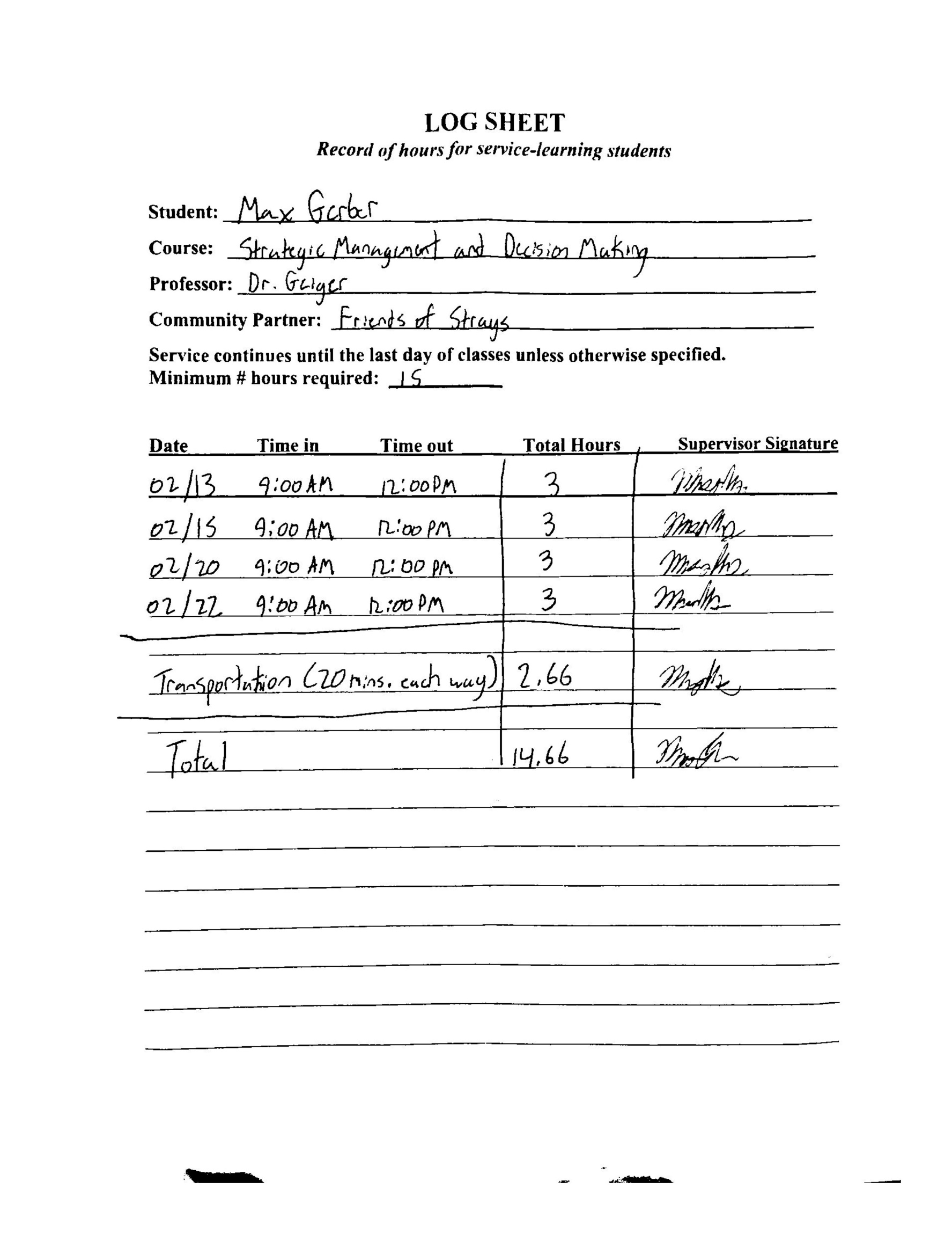**Service Hours Log**

**Photos**

